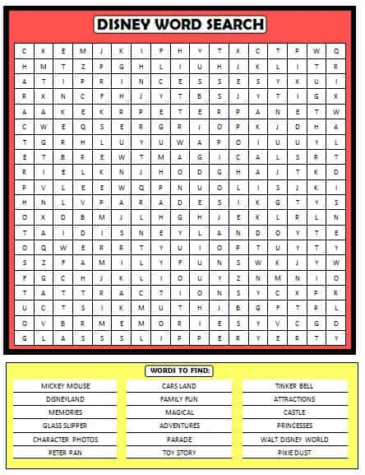
Resource from: www.momsandmunchkins.ca

