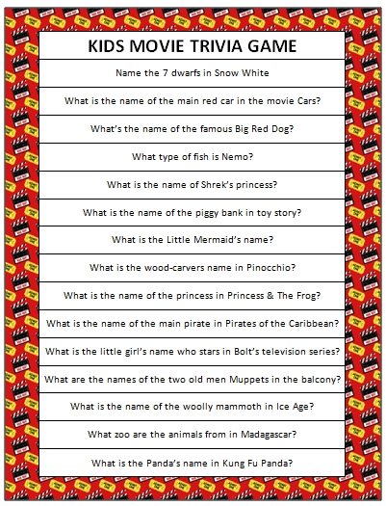
Resource from: www.monsandmunchkins.ca

